ASSIGNMENT 1 (Binary Search)
CSE 246
Name: Zannatul Hasan Roza
ID:2024-3-60-246

1.
#include <bits/stdc++.h>
using namespace std;
int firstOccurrence(int A[], int trgt ,int N) {
int BEG = 0,
END = N - 1;
int f = -1;
while (BEG <= END) {
int mid = (BEG + END) / 2;
if (A[mid] == trgt) {
f = mid;
END = mid - 1;
}
else if (A[mid] < trgt) {
BEG = mid + 1;
}
else {
END = mid - 1;
}
}
return f;
}
int lastOccurrence(int A[], int trgt, int N) {
int BEG = 0,
END = N - 1;
int l = -1;
while (BEG <= END) {
int mid = (BEG + END) / 2;
if (A[mid] == trgt) {
l = mid;
BEG = mid + 1;
}
else if (A[mid] < trgt) {
BEG = mid + 1;
}
else {
END = mid - 1;
}
}
return l;
}
int main() {
int N;
cin >> N;
int A[N];
for (int i = 0; i < N; i++) {
cin >> A[i];
}
int trgt;
cin >> trgt;

int f = firstOccurrence(A,trgt,N);
int l = lastOccurrence(A,trgt,N);
cout << f << " " << l << endl;
}
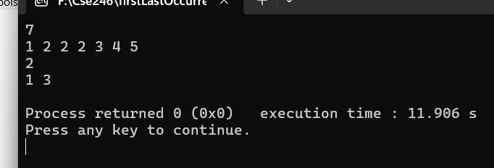

2.
#include <bits/stdc++.h>
using namespace std;
int upperBound(int A[], int N, int S) {
int BEG = 0,
END = N - 1;
int ans = N;
while (BEG <= END) {
int mid = (BEG + END) / 2;
if (A[mid] > S) {
ans = mid;
END = mid - 1;
} else {
BEG = mid + 1;
}
}
return ans;
}
int lowerBound(int A[], int N, int S) {
int BEG = 0,
END = N - 1;
int ans = 0;
while (BEG <= END) {
int mid = (BEG + END) / 2;
if (A[mid] <= S) {
ans = mid;
BEG = mid + 1;
} else {
END = mid - 1;
}
}
return ans;
}

int main() {
int N, S;
cin >> N >> S;
int A[N];
for (int i = 0; i < N; i++) {
cin >> A[i];
}
int ub = upperBound(A, N, S);
int lb = lowerBound(A, N, S);
cout << ub << " " << lb << endl;
}

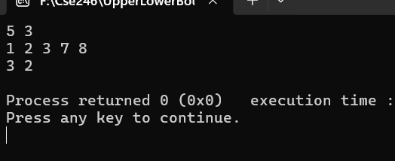

3.
#include <bits/stdc++.h>
using namespace std;
int main() {
int N;
cin >> N;
double BEG = 0, END = N;
double mid;
while (END - BEG > 1e-6) {
mid = (BEG + END) / 2;
if (mid * mid <= N) {
BEG = mid;
} else {
END = mid;
}
}
printf("%.3f\n", BEG);
return 0;
}
